PERSMAP
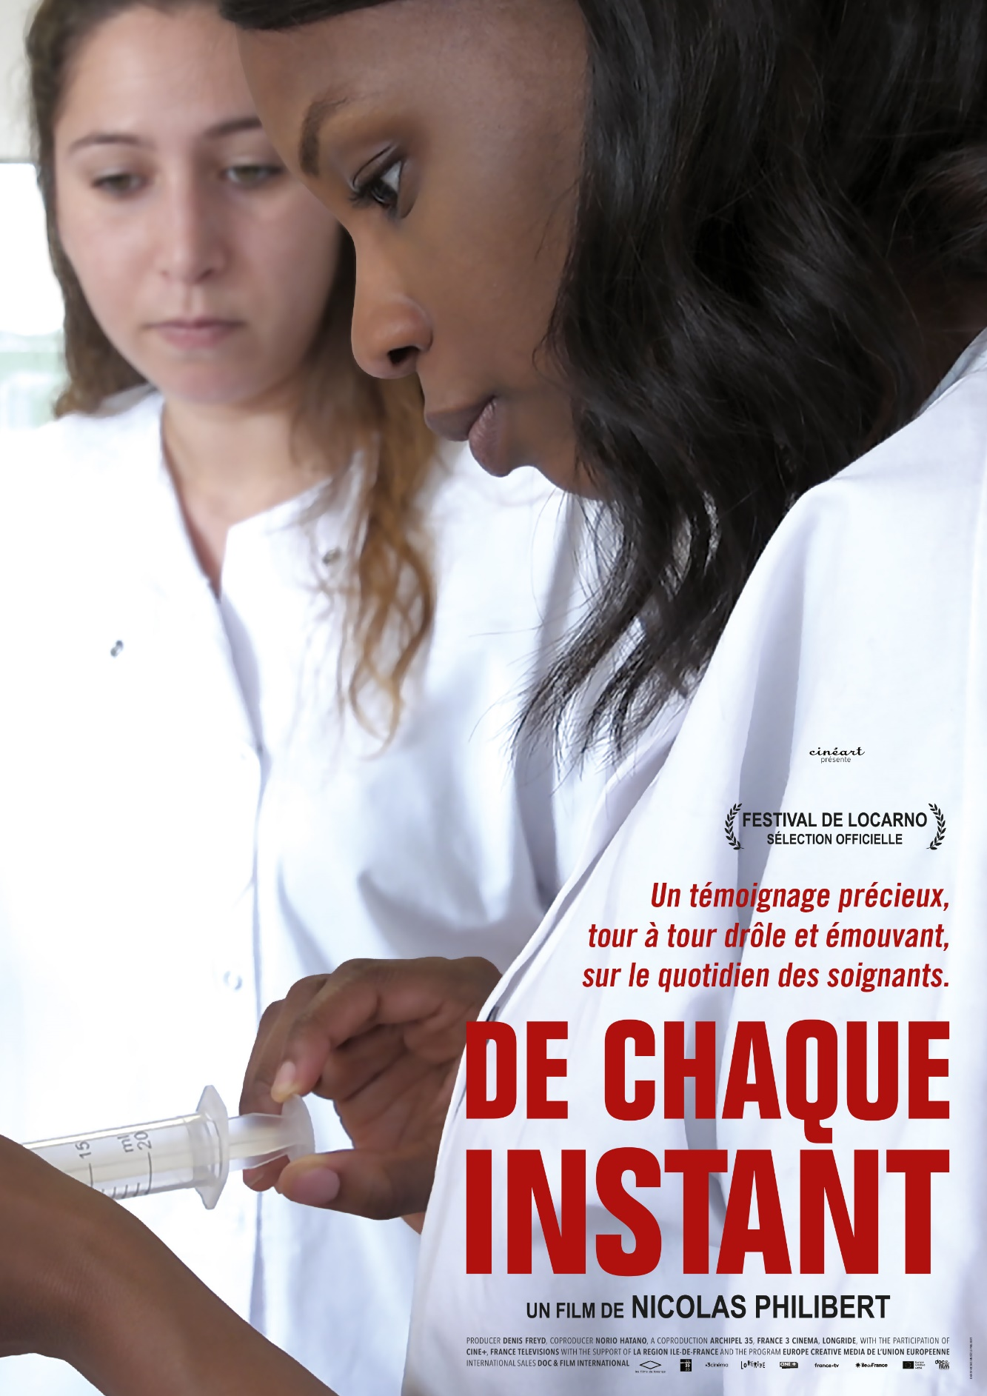

De chaque instant
Een film van Nicolas Philibert

DE CHAQUE INSTANT is de nieuwe documentaire van Nicolas Philibert, bekend van de zeer goed bezochte en met prijzen overladen ÊTRE ET AVOIR. Elk jaar beginnen tienduizenden jonge mensen aan een studie verpleegkunde. De studenten volgen een intensief en moeilijk parcours, waarbij ze veel kennis opdoen, talrijke technische handelingen leren beheersen en zich voorbereiden op grote verantwoordelijkheden. Ambitie en idealisme gaan hand in hand.

DE CHAQUE INSTANT toont de hoogt- en dieptepunten van een leerproces waarin de jonge studenten geconfronteerd worden met lijden, ziekte, gewonde zielen en gewonde lichamen. Een film over ons en onze menselijkheid.

Speelduur: 100 min. - Land: FR - Jaar: 2018 - Genre: Documentary
Releasedatum bioscoop: 5 december 2018
Meer over de film:
http://www.cineart.be/nl/films/de-chaque-instant
Persmaterialen:
http://www.cineart.be/nl/presse/de-chaque-instant

Distributie Pers
Cinéart Brigitta Portier
Naamsestraat, 72-74 T. 0477 98 25 84
1000 Brussel brigittaportier@alibicommunications.be
T. 02 245 87 00
Nursing Training
There are currently over 330 Nursing Training Institutes in France. Often attached to a hospital, they vary in size. The largest can accommodate up to 300 students in each year, the smaller ones around forty. The majority of them are public, but there are also private institutes, such as those attached to a private hospital group or the Red Cross. Teaching methods may vary from one institute to the next but they must all respect the same «competency framework» and prepare students for the same state diploma.

During their training, each student will have to do six internships, one per semester. There are four types, each representing a «range of situations»: an internship in «acute care», in other words in hospitals; an internship «in mental health and psychiatry,»; an internship in «long-term care, follow-up care and rehabilitation» with patients requiring continual care following an acute situation, an accident or an operation, in order to restore their independence and facilitate their return home; and, finally, an internship in «individual or collective care, in a communal setting», that is to say in a kindergarten, a nursing home, a home care service, a home for the disabled, a health care reception centre, etc.

Each student is required to complete at least one internship in each of these categories and thus has the opportunity to discover a wide range of situations, approaches and personalities. A diversity that will enable her to enrich her healthcare culture and build her own identity. Little by little, she will be led to refine her image of the profession according to the models, situations or even patients that she encounters.

Each year, more than 30,000 students embark upon these studies. Men represent around 12% of the intake.

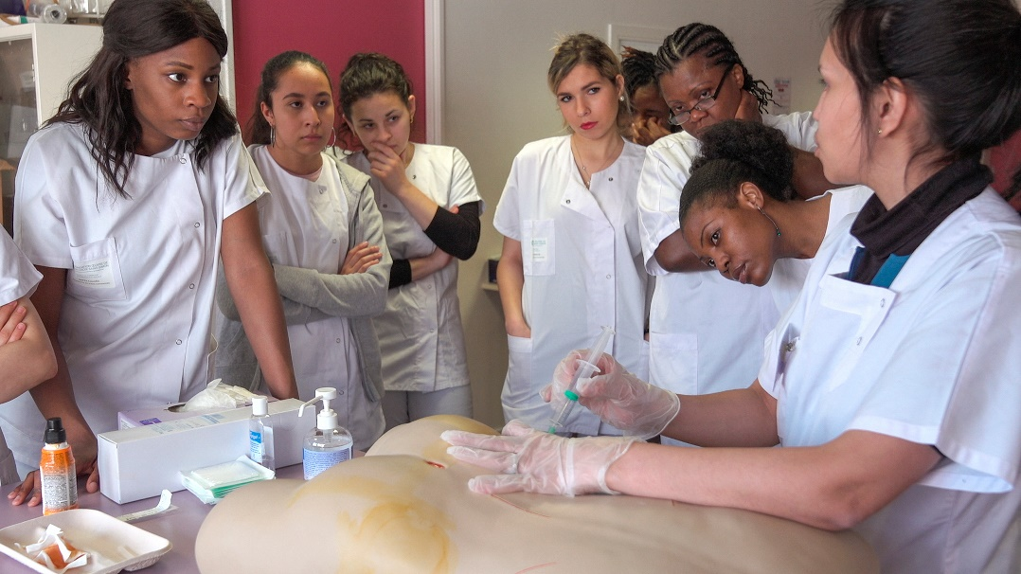

Nicolas philibert - director
Filmography

2018 DE CHAQUE INSTANT
2013 LA MAISON DE LA RADIO
Selected for the Berlin Festival (Panorama), French Press Etoile d’Or, Tiempo de Historia Award (Valladolid), selected for festivals in Telluride, London, Istanbul, Sydney, Tübingen, Jerusalem, Melbourne, Stockholm, Thessaloniki, Saint Petersburg, Vancouver, Rio de Janeiro, Tromso (Norway), Morelia (Mexico), Cluj (Romania), Santiago (FIDOCS), Buenos Aires (FIDBA) Copenhagen (CPH Dox), Helsinki (Doc Point), Lisbon (Doc Lisboa), Warsaw (Planet Doc), etc.
2010 NÉNETTE
Selected for the Berlin Festival (Forum), Best Director Prize at the RiverRun Film Fest (USA), selected for festivals in Vienna (Viennale), Edinburgh (EIFF), Nyon (Visions du Réel), Helsinki (Doc Point), Warsaw (Planet Doc), Toronto (HotDocs), San Francisco
2010 LA NUIT TOMBE SUR LA MÉNAGERIE
2007 RETOUR EN NORMANDIE
Official Selection - Festival de Cannes (Out of competition)
2002 L’INVISIBLE
2002 ÊTRE ET AVOIR
Official Selection - Festival de Cannes (Out of competition), Prix Louis Delluc, French Press Etoile d’Or, Listeners’ Award from the radio show Le Masque et la Plume, Prix Méliès from the French Critics’ Union, Cesar nominations as Best Director, Best Film, Best Editing, Cesar for Best Editing, BAFTA nomination, Prix Humanum (Belgian press), Best Non-fiction film Award (National Society of Film Critics, USA), Grand Jury Prize at Full Frame Film Festival (USA)
1999 QUI SAIT ?
1997 LA MOINDRE DES CHOSES
Official Selection - Locarno Festival (Out of competition), Audience Award at the Rencontres de Cinéma in Paris, Audience Award at the Festival du Cinéma et des Nouveaux Médias (Montreal), Best Documentary at the Potsdam Festival, Grand Prize at the Amascultura Festival (Lisbon), Golden Spire (San Francisco)
1995 UN ANIMAL, DES ANIMAUX
Best Research Film at the Festival dei Popoli (Florence), Golden Gate Award (San Francisco)
1993 LE PAYS DES SOURDS
Official selection at the Locarno Festival (Out of competition), Grand Prize at the Belfort Festival, Grand Prize at the Festival dei Popoli (Florence), Grand Prize at the Vancouver Festival, Humanum Prize awarded by the Belgian press, Grand Prize at the Bombay Festival, Golden Gate Award (San Francisco), Stephanie Beacham Award (USA), Peabody Award (USA)
1990 LA VILLE LOUVRE
Prix Europa (Best Documentary 1990), Intermédia Prize at the Cinéma du Réel Festival.
1988 LE COME-BACK DE BAQUET
Grand Prize at the Autrans Snow and Ice Festival, Audience Award at the at the Antibes World Mountain Film Festival, Best «Mountainfilm Spirit» at the Telluride Mountain Film Festival (USA), Special Jury Award at the Banff Festival (Canada)
1988 VAS-Y LAPÉBIE !
1987 TRILOGIE POUR UN HOMME SEUL
Grand Prize at the Hakuba Adventure Sport Film Festival (Japan), Diable d’Or at the Diablerets Alpine Film Festival (Switzerland), Grand Prize at the Antibes World Mountain Film Festival, Special Jury Award at the La Plagne Adventure Sport Film Festival
1985 CHRISTOPHE
Grand Prize at the La Plagne Adventure Sport Film Festival, Diable d’Or at the Diablerets Alpine Film Festival (Switzerland), Best Mountaineering Film Award at the Banff Festival (Canada)
1978 LA VOIX DE SON MAÎTRE
1979 PATRONS/TÉLÉVISION co-directed with Gérard Mordillat
INTERVIEW WITH NICOLAS PHILIBERT
How did this project come about?
I had been circling this idea for a while, when Providence sent me to do scouting: in January 2016, an embolism put me straight in the emergency room and then in an intensive care unit. That was the trigger. When I was back on my feet, I decided to make this film, as a tribute to healthcare staff, especially nurses.

Why did you choose to focus on the learning stage? After Le Pays des sourds and Être et avoir, what led you in that direction again?
Learning situations allow a director to film the foundations, highlighting what time and experience end up making imperceptible. When you see a nurse performing ordinary treatment, an injection or a blood test, say, it seems quite simple, it’s easy. Unless you’re in that line of work, you cannot imagine all the mistakes that she has learned to avoid, the rules of hygiene, the protocols, the thousand and one little things that dexterity has gradually erased. Filming classes and practical work sessions can be repetitive, funny, mysterious, comical or exciting, things sometimes hang by a thread, but from a dramaturgical point of view, it’s very fruitful. Seeing students grope, make mistakes and start again, following them in their efforts makes them appear closer and more human: will they succeed? How should they have gone about it? And would I be able to do the same? In short, we side with them, we can identify with them. And filming them learning also means filming desire. The desire to learn, to improve. The desire to graduate, to fit into society, to make oneself useful. The nursing profession is difficult, exhausting, poorly paid, often discredited within the hospital hierarchy, and yet it remains attractive and benefits from an excellent image in the mind of the general public. Indeed, this somewhat idealized image is often at the origin of the decision to become a nurse.

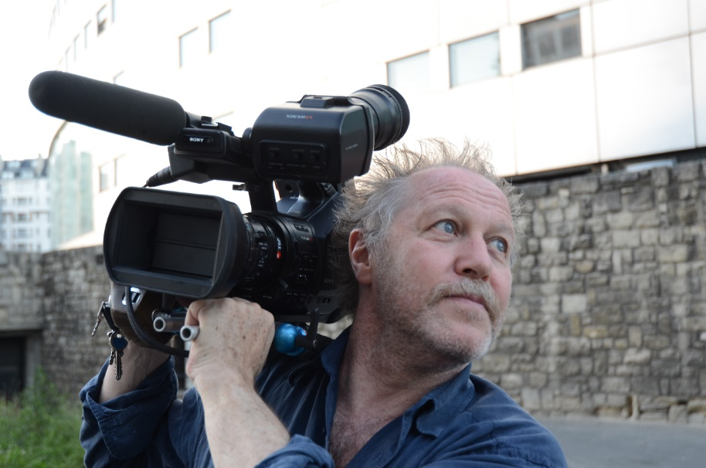

What made you choose the Institut de la Croix-Saint-Simon?
I wanted to shoot in Paris or in the inner suburbs, preferably not too far from home, so as not to lose too much time on the commute. I visited six or seven training institutes out of the sixty or so in the Île-de-France Region. The Croix-Saint-Simon team in Montreuil quickly became involved. The great cultural and social diversity of the students also played a role. In these days of retreat into nationalist ideas of identity, I liked the idea of filming young people ready to embark on a career focused on others. And, finally, the Montreuil Institute is a «human-sized» school: there are «only» 90 students per class. As the course lasts three years, that still makes 270 students in the whole sector and, within the framework of a shoot, that is quite a lot, but some institutes welcome three times as many. La Pitié-Salpêtrière in central Paris has nearly 1,000 students! Things turned out this way, but I must point out that the Institut de la Croix Saint-Simon is a private institution «recognized as a public utility». Private does not mean that the students come from a wealthy background. Like the population of the area in which it is located, most of them are from a modest background, and the Île-de-France Region, as well as various vocational training organizations, covers their tuition fees. Moreover, it is a secular establishment. Its name is explained by the fact that at the time of its creation, the foundation on which it depends was located rue de la Croix Saint-Simon, in the 20th arrondissement of Paris.

What initial decisions guided your work on the film?
The idea of filming both classes and practical sessions, of following a few students in internships and then of recording the account of their internships was present from the beginning of the project. With classes, we’re still in the realm of the virtual and theoretical. Everything is «fiction»: patients only exist on paper. With practical sessions, they practice on models, sometimes on another student, even on an actor, but they remain at a distance. The start of the internship is the encounter with reality. With real patients, with illness, suffering, and sometimes the end of life. The shock is often
quite harsh and, for many students, it is a test. Simply touching a body is not self-evident. It can make them uncomfortable or cause anxiety. But it is also the encounter with economic reality, the lack of means, under-staffing, stress, the increase in the number of tasks, the tensions that weigh on one department or another... Faced with the obligation of efficiency, the fine principles which were instilled into them at school, based on listening and attention to patients, are quickly put to the test. Hence the importance, in the third part of the film, of collecting the “feedback from the internships”, these exchanges with their instructors during which they can begin to “elaborate” on the discrepancy between their aspirations and this confrontation with reality, express their feelings, evoke what the encounter with illness produces in them, with specific patients, pathologies, types of care or technical gestures. These moments are all the more precious today because the world of healthcare, increasingly subservient to management, to “efficiency”, no longer seems to bother much about the feelings of carers, even though we know that the quality of healthcare depends to a large extent on the way they can develop it, on the possibility of expressing it in words, of putting their emotional experience at a distance.

The film does not directly denounce these economic aspects, nor the suffering of hospital staff, nor the catastrophic situation caused by under-funding and cutbacks in retirement homes… So what was your intention?
My project was not to make a film denouncing the situation, much less a pamphlet or a political piece. My intention? I feel fully in phase with André S. Labarthe, who said: “The enemy is intention” before adding, “Direction is what makes it possible to erase any trace of intention.” Besides, films always say something else - and other things - than what we wanted to say, make them say, or thought they had said. They have to retain some secrecy and leave questions unanswered. The difficulties in our health care system and the pressures on caregivers, without being at the forefront, nonetheless form the background of the film. The instructors and students refer to them more than once, and it seems to me that the political dimension of the film is no less real. Giving future carers, who are destined to remain in the shadows, a voice, showing their determination, their dignity, but also their fears, doubts and fragility, is in itself a political process. The efforts and sacrifices that many of them have to make in order to pursue their studies - while working at the same time - are perceptible in the film. Moreover, the interviews they have with their “referents” allow us an insight into many aspects of the caregiver-patient relationship, a relationship that is by definition asymmetrical, in which the dimension of power, far from being anecdotal, must be worked on in order to be contained.

Weren’t you tempted to reduce the number of protagonists and focus the film on three or four students?
That was discussed at the beginning, but we soon ruled out the idea. I couldn’t see myself making a selection among the students, especially when most of the practical work is done in groups. Very quickly, on the contrary, I wanted to take advantage of the collective aspect. The social mix of the students was an asset for the film. It would allow me to paint a very contemporary portrait of our healthcare personnel and of France today. Among the students there are some that we recognize, we see them at the school, we find them in internships or in their interviews, but this is not systematic. The film is not based on that. I could also have chosen to film only students from the same class, the “first year” for example. It is true that they are the ones we see most in the first part, but in the internships and in the interviews we also see second and third-year students. Their internships are increasingly technical, with greater responsibilities. The film does not try to say explicitly where each student is in her journey, but in some interviews, we occasionally learn this from a turn of phrase.

When did the idea of constructing the film in three parts arise? Was it planned from the beginning?
Initially, I imagined that the film would switch back and forth between classes, internships and internship reports, but as soon as I started editing I realized that would unnecessarily complicate the story, and the idea of a construction in three parts, in three “movements”, imposed itself. I like to use this word, usually reserved for music, because I think it clearly expresses how each part unfolds in a key and with a melody distinct from the other two. Moreover, this very simple narrative principle would allow me to create a kind of crescendo, with the film gradually gaining in intensity and emotion.

Do you think your presence altered the behaviour of the people you film? What impact did it have during the classes and practical sessions?
You have to try to be as discreet as possible, as unsettling as possible, but no matter how you do it, the presence of a camera, a boom or a crew, however small, always has an impact on reality. Personally, I film openly, with my presence clear to the person filmed. Sometimes, when people pretend not to see you, that’s a little too obvious. So I tell them, “Pretend I’m here!” Therefore, in my films, people can glance at the camera. As long as such looks aren’t too obvious, I don’t mind. Why should we make the audience think we weren’t there? A few days ago, in the exhibition devoted to him at the Cinémathèque française, I came across these words by Chris Marker which delighted me: “Was there ever anything more stupid than telling people, as they teach in film schools, not to look at the camera?” Of course, not everyone approaches the camera in the same way. At the Institute, out of all three years, a few dozen students did not want to be filmed. In certain situations, I therefore had to define a blind spot, indicate an area off-camera that they could occupy without being disturbed in their training.

Was it difficult persuading the patients to be filmed?
Almost everyone I approached accepted spontaneously. As soon as I explained what we were doing, they would say, “Go ahead! This is important! We need the nurses!” and so on. I never had to insist. Fortunately, because I hate that.

In the second part, among the internships, there is a sequence that contrasts with all the others. We are outdoors, there are no white coats, no medical equipment...
During their studies, nursing students are required to complete internships in different types of facilities: health centres, hospitals, schools, psychiatric hospitals, retirement homes, home care, etc. They thus learn not only to provide technical care but also other forms of accompaniment. Here, we are in a shared garden, in the heart of Paris, where patients and psychiatric nurses come to work every week. For me, it is an important scene, not only because it presents another facet of the nurse’s role, but because it is a good example of how personal relationships as such are an essential element of care.

As viewers, we can identify at times with the student nurses and at others with the patients…
That’s right. In our imagination, we go back and forth between the two, asking ourselves if we would feel capable of giving a shot, of cleaning a wound, and then, the next moment, thinking that in the event of a problem, we would like to be in the hands of a nurse who is sure of herself and experienced. Some of the footage at the hospital refers us back to our personal history, or to our loved ones. In our entourage, we all have relatives, friends who are sick, or who have been sick, and we know that we ourselves may one day be sick too. This is how the film goes beyond its subject. As is often the case with me, the “subject” is, if not a pretext, at least a doorway. Beyond the apprenticeship of the nursing profession, the film speaks to us about our fragility, human fragility.

The third part of the film gathers very moving testimonies. How easy was it for students to tell their stories in front of the camera?
Those whose internships had gone well were quite happy to do it, but for those who had experienced difficulties, it was a little more complicated. Would they agree to talk about situations in which they were not necessarily to their advantage? A few refused, but most played along, so I ended up collecting about 60 interviews. I kept thirteen. So that they would not feel trapped, I undertook to leave the room before the interview was over, giving them a space to speak without witnesses. If they wanted to talk about something very personal, about dysfunction, abuse, injustice, hostility in a healthcare setting... they could do so after we left. Their words should not penalize them or turn against them. So that they would know that they were protected, I said that the location of their internship would not be revealed and invited them to observe the same rule. Of course, I also had to preserve the anonymity of the individuals and institutions involved.

How did you avoid all compassion and voyeurism?
You’ll notice that I was not the one conducting these interviews, but the institute’s instructors, ensuring the quality of the exchanges. For my part, when I felt that our presence might be detrimental to a student, I offered to stop filming. We did it once or twice. Editing took care of the rest. Filming someone also means imprisoning them, locking them in an image. You have to be careful what you leave behind. The film is one thing, but there’s the period that comes after it too.

How did this film change your perception of the nursing world?
There’s a lot to say. Each time you approach a reality, you discover its richness and complexity, your perceptions are shaken, the clichés vanish...

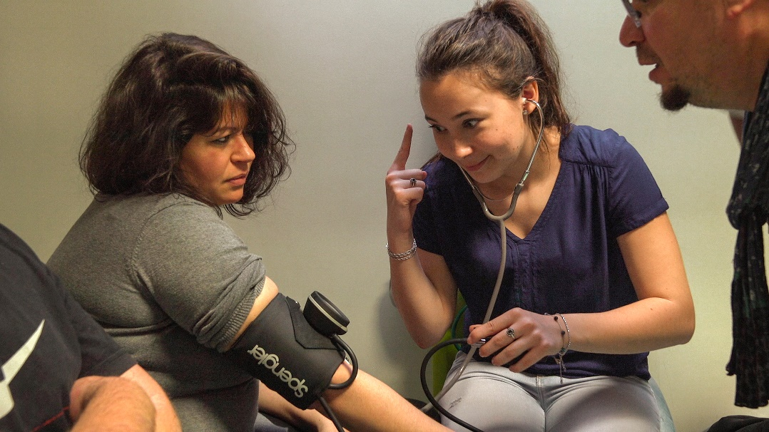
You operate the camera on your films yourself, you edit them...
I started operating the camera twenty-five years ago, during the shooting of Un animal, des animaux: the cameraman I was working with could not continue. Until then I had always worked with one. At first, I hesitated about replacing him, but finally decided to take the risk, with the complicity of an outstanding assistant. Then the shooting of La Moindre des choses came along and I chose to film it myself from A to Z. I was uneasy in the psychiatric clinic of La Borde and felt that the camera could both protect me and allow me to go towards people. Since then, I have never looked back: I have continued to shoot my films myself. When I first took up the camera, the idea was not to do the job better than a professional, with more “beautiful” or neater shots, but to have control over framing, so as not to give in to the temptation of showing everything; I felt that it was in this tension, this resistance, that things would be played out. Today, in the digital age, in the age of small cameras, of “total visibility” into which we are inexorably sinking and of the threats that weigh more and more on the private sphere, this question seems more important than ever: the frame, the border between what is in and off camera, is not only a matter of aesthetics, it is an ethical and political issue...

And editing?
I worked with an editor for a long time, but now I edit alone. I enjoy it very much. I need this lonely journey, this time facing myself. But I do have some accomplices. Every now and then I show them where I am. And for all the technical aspects, I have an assistant. As soon as I have a problem, I call him and he explains how to solve it.

Have the students and instructors seen the film? And, if so, how did they react?
As soon as the film was finished, we organized a screening for all of them at the Méliès in Montreuil. I was a little nervous. How would they react? What about the ones I cut in editing? During shooting, I had more than once had the opportunity to evoke these questions in front of them, to prepare them, to explain that montage obeys all kinds of considerations, that the director can end up discarding fantastic sequences... but there is a difference between theory and experience. Besides, when you have had the opportunity to participate in the adventure of a film and you see it for the first time, you experience that screening in a particular way, it’s normal: you wonder if you’re still in the film, you look out for the moments when you’re going to appear, etc. However, at the end of the screening, I was surprised to see that their reactions went far beyond their own presence. They were very sensitive to the general movement of the film, they found themselves in the words of others, recognized themselves in this collective portrait. For the students, as for the instructors, I have the impression that it has become “their” film.

Apart from the final credits, why is there no music in the film?
I saw no need to add any. The soundtrack is deliberately uncluttered. It is composed almost exclusively of direct sound, the grain of the voices. Not the slightest effect, no artifice. Formally it is a very simple film, without frills. I wanted us to keep as close to the words as possible.

CREW
Camera Nicolas Philibert
Assisted by Rémi Jennequin
Aurélien Py
Camille Clément
Pierre-Hubert Martin
Cécile Philibert
Sound Yolande Decarsin
Editing Nicolas Philibert
Assisted by Janusz Baranek
Sound editor Romain Ozanne
Sound mixing Emmanuel Croset
Colour grading Christophe Bousquet
Production assistent Cécile Philibert
Line producer Cédric Ettouati
Co-producer Norio Hatano
Producer Denis Freyd
Produced by Archipel 35
France 3 Cinéma
Longride
With the participation of Ciné +
France Télévisions
and Les Films du Losange
Doc & Film International
Blaq Out / UniversCiné

With the support of Région Île-de-France
In partnership with CNC
and European Union Europe Créative
MEDIA program

With the Supervisors and nursing students of the IFPS of the Fondation OEuvre de la Croix Saint-Simon, Montreuil

This film was made with the complicity of Linda De Zitter

